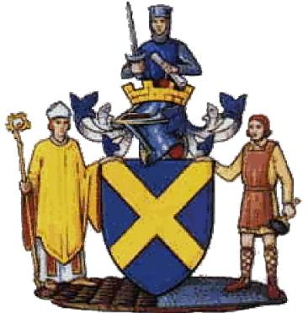

St Albans Primary Schools

Season 2023/24

Yellows v Slough 10:30am
SCL/CL
Girls v Slough – 11:35am
SCL
Saturday 9th December 2023

Colney Heath School/FC

St Albans Primary Schools Football Association
Officers

Chairman Duncan Burgoyne
Secretary and ESFA rep Bob Bridle
District Yellows Manager Nick Sanders,
District Blues Manager Tom Spratt
District u10 Manager Michael Clements,
District Girls Manager David Oswin
Coaches Tom Johnson, Tabs Stacey, Dave Sandiford
Results Secretary Mark Turpin
Child Welfare Officer Duncan Burgoyne

The St Albans Primary Schools Sports Association is affiliated to the E.S.F.A and runs a thriving programme of schools football for all schools in the St Albans area. We have 9 Boys leagues and 5 Girls leagues that run throughout the season. Schools also have the opportunity to enter the St Albans Cups, with the semi finals and finals held at Clarence Park, the home of St Albans City FC. At County level, many St Albans schools enter the Wix 7 a side shield, the Girls Wix 7 a side competition and the Wix 9 a side competition, which is the oldest schools competition in the County.
The St Albans Primary schools U11 District team has really flourished since the mid eighties. Over the last few years, this has been run by the partnership of Nick Sanders, Tom Spratt, Tom Johnston and Alex Gates. The District team has won the Hertfordshire league on several occasions, The Berkshire/Southern League 3 times, along with the Witney/Shires Cup and Southern Counties Cup, which is the most prestigious Cup in the Country. St Albans have also been in the finals on several other occasions. Recently, the Association has also a District Girls side run by David Oswin
The success of our District teams has ensured that the reputation of schools football continues to go from strength to strength. We are proud to be a much respected association and proud of the opportunities that children have in our District.
With the support of our Chairman, Duncan Burgoyne, and a dedicated team of teachers, we are confident that our association will continue to deliver an excellent standard of schools football across the district.

Bob Bridle
Secretary, St Albans Primary Schools Football Association

Our Aims

- Improve individually as a player
- Contribute to the performance of the team
- Help other members of the squad
- Develop positive attitudes towards winning and losing
- Tackle new challenges in a positive manner
- Make new friends and meet new people
- Respect other people and appreciate all who give up time to help them – teachers, match officials, parents and opponents
- Represent their School and City in an honourable manner
- ENJOYMENT

Codes of Conduct

For Players

- Play for the fun of the game, not just to please the coach or parents
- Always play by the rules
- NEVER question the referees or assistant referees decision
- Always control your temper
- Work hard for the team and yourself
- Be a good sport
- Treat other players as you would want to be treated yourself

For Parents

- Remember that children are involved in sport for their enjoyment, not yours
- Always encourage your child to play by the rules
- Teach your child that losing must be accepted without undue disappointment
- Never ridicule children for making a mistake
- Never question the officials judgement or their honesty
- Do not coach either your child or other team members during the game

St Albans Primary Schools Squads 2023/24

Yellows squad | Blues squad | Girls squad | Development
Joshua Cordery | Bertie Rowland | Phoebe Allen | Lucien Thompson
Max Gibbons | Ben Edwards | Mimi Boxill-Roope | Ted Burgoyne -Richards
Jordan Griggs | Oscar Rowland | Sophia Ashcroft | Nick Foster
Jack Carter | James Dyer | Martha Mellors | Maxwell Gibson
Evan Tolley | Henry Pidgeon | Josie Henrikson | Joshua John
Sam Hodgkinson | Arthur Ellis | Holly Sizer | Jack Hine
Eden Kosh | Ale Ponzo | Megan Duncan | Freddie Moule
Ollie Hawkes | Louie Burt | Jessica Edwards | Tom Nicholson-Wolfe
Rasmus Duncan | Sam Brierley | Anna Dibbs | Sam Norton
Buddy Beeby | Trey Joseph | Ava Jones | Joseph O’Sullivan
Albie Trollope | Danny Kennedy | Jessica Barrett | Tristan Phillips
Charlie Stewart | Jack Griffiths | Lara Taylor | Ethan Rance
Sandro Mendez-Barral | Kymani Samuda-Norton | Alice Mansfield | Callum Leith
Finlay Holian | Tom Hutton | Olivia Carr | Franky Osborne
 |  | Mary-Catherine Anderson
 |  | Isla Kelly

Honours Board
Southern Counties Cup
Winners 1995/96, 2010/11
Runners Up 2002/03, 2005/06, 2017/18

Shires Cup
Winners 2002/03, 2010/11, 2015/16,
Runners Up 2003/04, 2016/17, 2019/20

Southern Counties League
Winners 2010/11, 2012/13, 2014/15
Runners Up 2011/12, 2017/18

Girls Southern Counties League
Winners – 2021/22

Cotswold League
Runners Up – 2020/21, 2021/22,

Cotswold Cup
Winners – 2021/22

Cotswold Shield
Winners 22/23

Hertfordshire League
Winners 2004/05, 2005/06, 2010/11, 2013/14, 2018/19
Runners Up 2007/08, 2011/12, 2016/17, 2017/18

Geoff Richards Memorial League
Winners 2016/17, 2021/22
Runners Up 2018/19

Southern Counties Intermediate Cup
Winners 2021/22

Southern Counties Plate
Winners 2021

ESFA National 7 a side County
Winners 1999/00, 2005/06, 2019/20
Runners Up 2002/03, 2007/08

ESFA National 7 a side Regionals
Winners 2005/06
Runners Up 1999/00

ESFA National 7 a side Finals
3rd place 2005/06

ESFA 9 a side Regionals
Runners up 2016/17

ESFA 9 a side Nationals
Runner up 2016/17
Runners Up 2016/17
All results for the above competitions can be found on the Gloucester Schools website, which is www.gpsfa.com
We also have our own website – sapsfa.co.uk

Our Opposition today

We welcome all the managers, coaches, players and supporters of Slough PSFA to St Albans and Colney Heath FC/School today and hope that they have had a safe journey and that they enjoy our hospitality.

Reggie Banks | CIPPENHAM
Xander Wishart | DEDWORTH
Aiden Mensah | LANGLEY HALL
Lorcan Daly | OUR LADY OF PEACE
Cassius Meyer | ST EDWARDS
Noah Southgate | ST EDWARDS
Edgar Jordan | ST EDWARDS
Jacob Clayton | ST EDWARDS
Max Zadlo | ST EDWARDS
Ikenna Nwodo | ST EDWARDS
Eddie Taylor | TREVELYAN
Blake Richardson | WESTERN HOUSE
ADDISON | BLAKE | DEDWORTH
PRINCESS | SAUIRARA | DEDWORTH
ELLIE | BICKLEY | DEDWORTH
LOLA | MARDON | DEDWORTH
DAISY | CHAPPELL | DEDWORTH
BAIORNE | LAKE | DEDWORTH
HARLEY | LANGLEY | DEDWORTH
LILY MAE | HUTTON | OUR LADY OF PEACE
ELSA | SANDRY-PERSSON | ST EDWARDS
BEATRIZ | HUMAN MUNOZ | ST EDWARDS
DESIREE | ODUFUWA | ST PETERS
AMABEL | SMITH | TREVELYAN
AMELIE | LE VESCONTE | TREVELYAN
SOFIA | PETTIT | UPTON HOUSE
ISABEL | SMITH | UPTON HOUSE
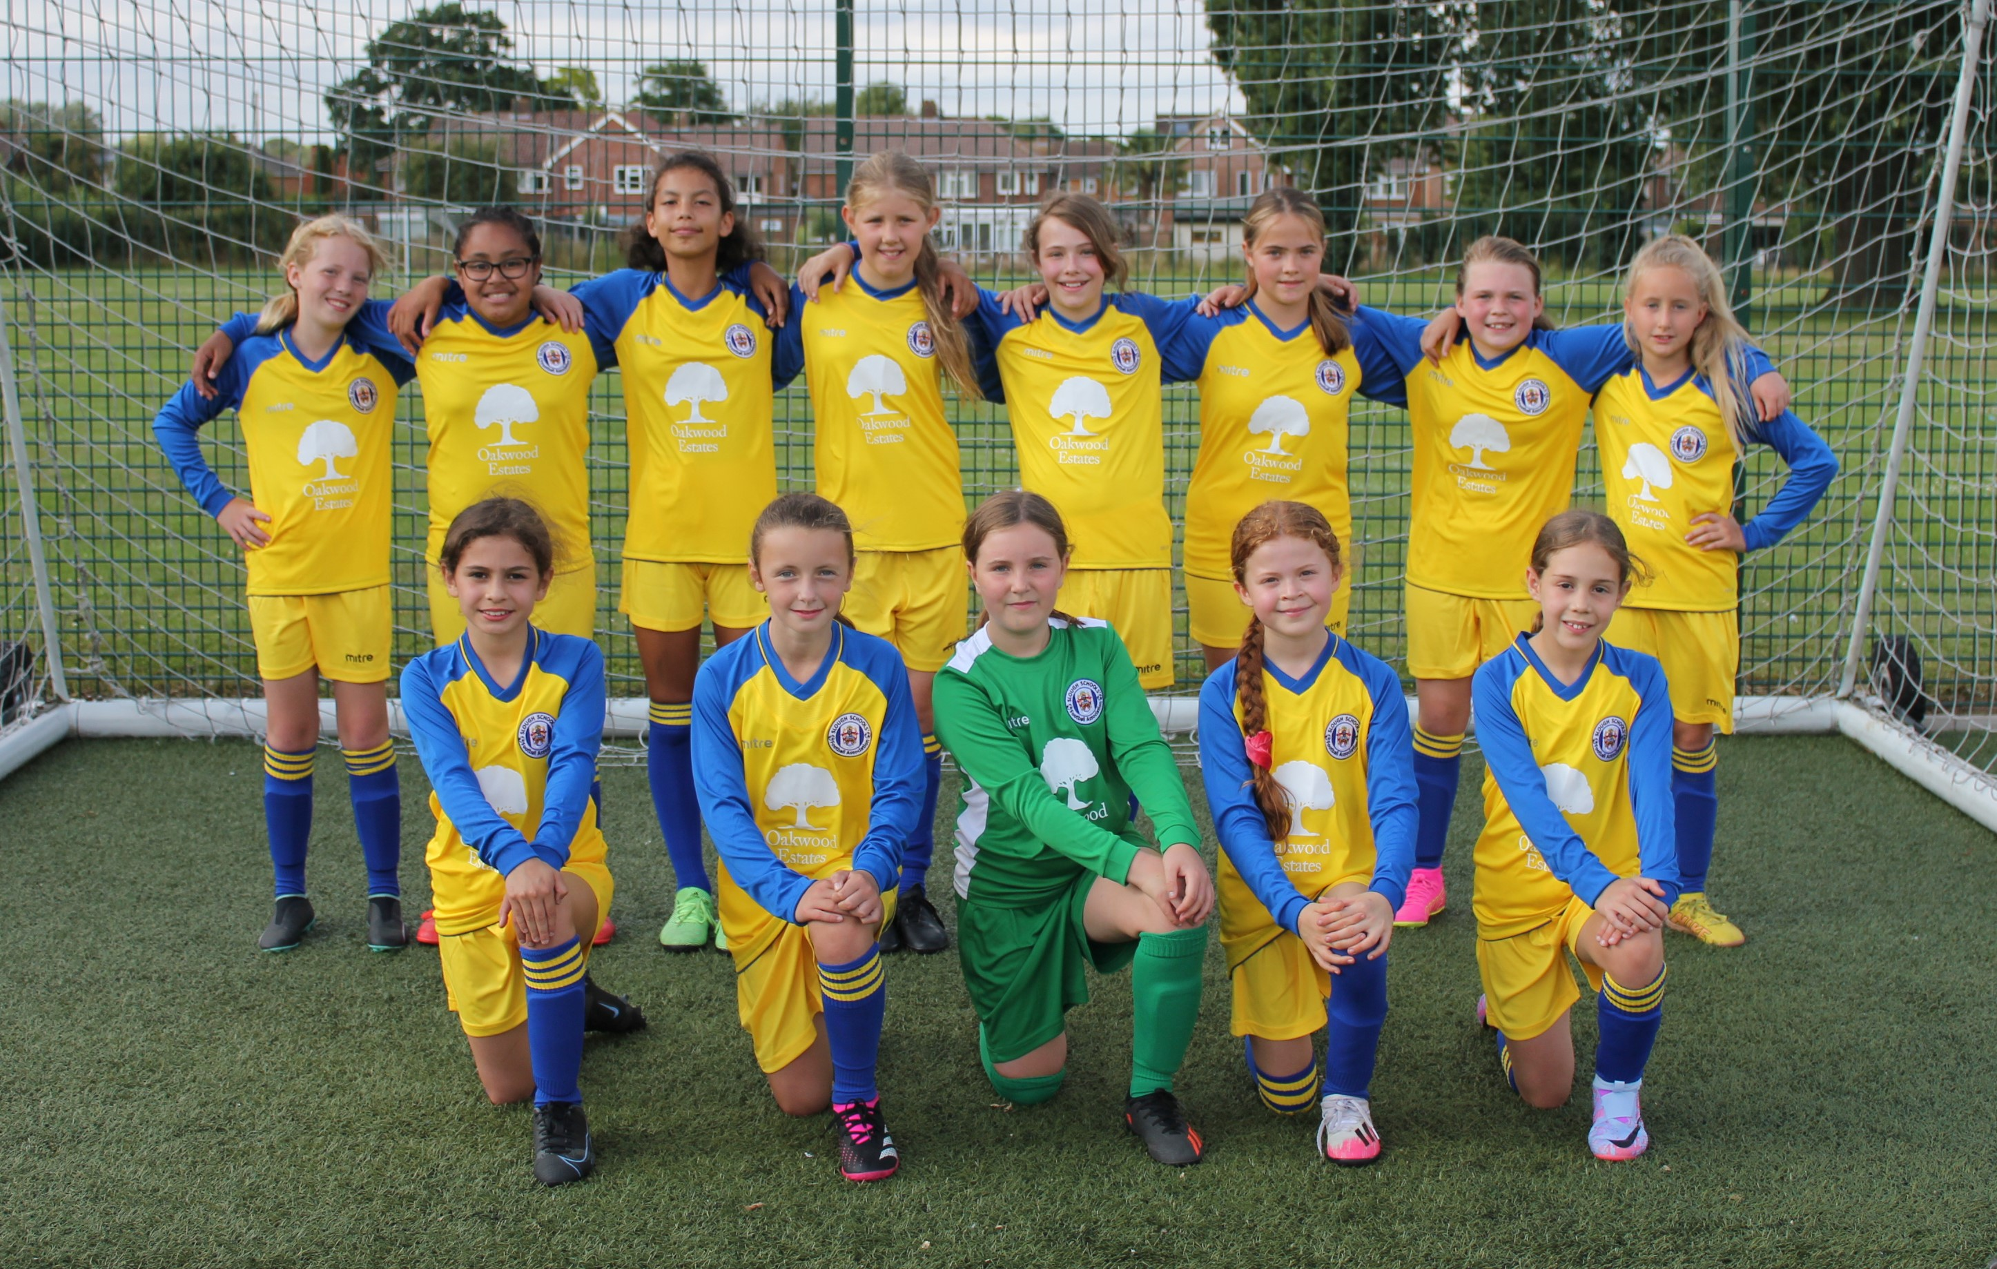
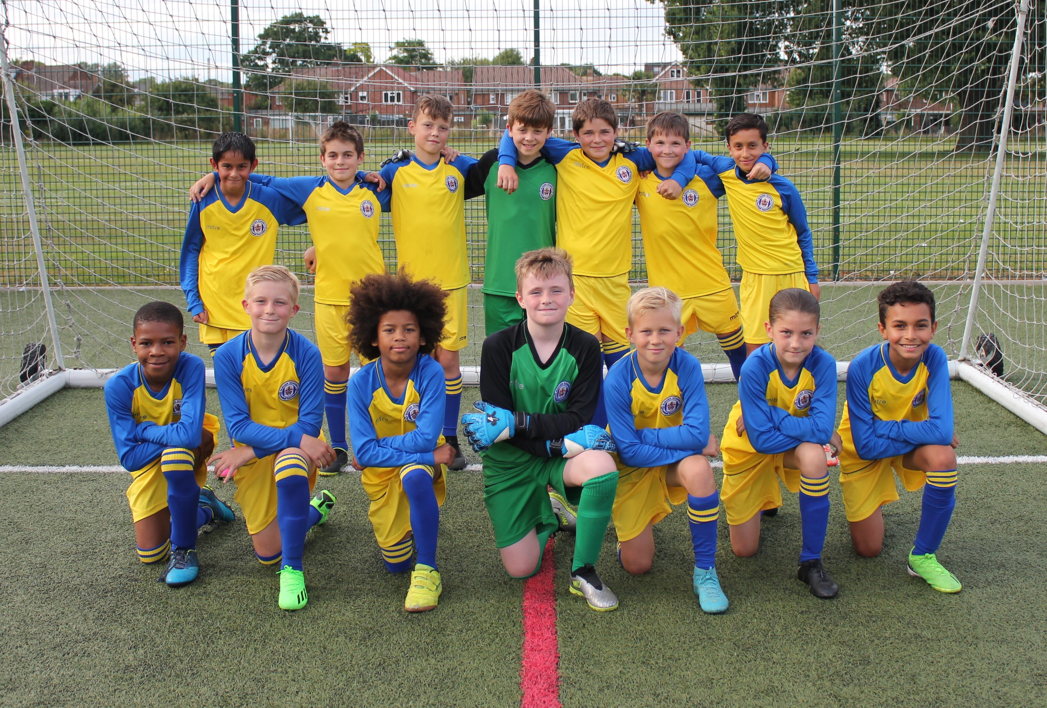

Please Respect
The Referee.
We are supporters of this campaign.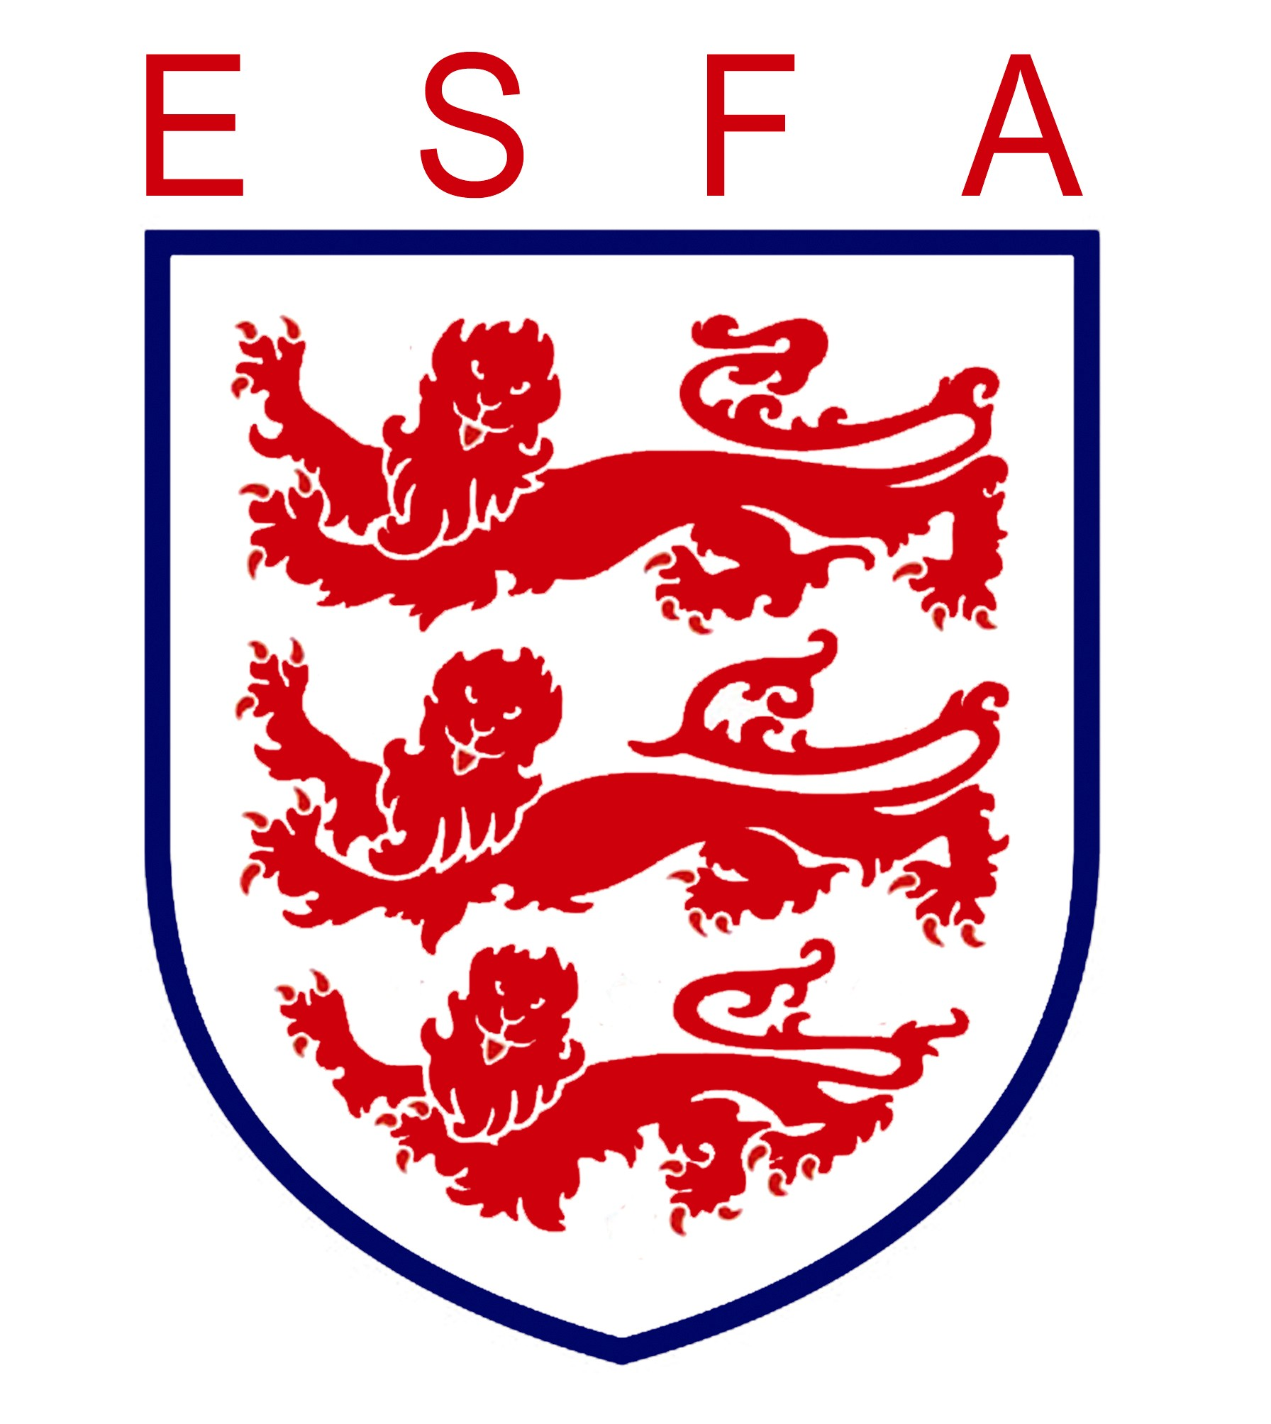

Our Sponsors –

948 Sports Foundation

Build4Space

We thank and appreciate our sponsors.
If you would like to be involved as a sponsor – please get in touch – stalbansprimaryschoolsfa@gmail.com

2023/24 Player Profiles

In today's programme, we have two of the Yellows Player's Profiles.

Name - Evan T
School - Killigrew
Nickname - Ev
Playing position - Centre midfield/full back
Favourite team - Watford
Best football moment - Scoring in the WFL finals
Worst football moment - Luton in the Premier League
Favourite food - Calamari
Favourite drink - Apple juice
Hobbies - Golf, cricket, running.
Favourite book - Alex Ryder (Stormbreaker)
Best subject - PE
Worst subject - Guided reading
Favourite singer/group - Elton John and Liam Gallagher
Favourite TV - Match of the Day
Favourite film - Happy Gilmour

Predictions 2023/24
Premier League - Man City
FA Cup - Man Utd
Champions League - Real Madrid
Relegated - Luton
Burnley
Wolves

Name - Finlay H
School - Killigrew
Nickname - Fin
Playing position - Defender
Favourite team - Man City and England
Best football moment - Scoring from a goal kick
Worst football moment - Holland losing to Argentina (2022 WC)
Favourite food - Dad's cooking
Favourite drink - Prime
Hobbies - Rounders, Basketball
Favourite book - Marcus Rashford – you are a champion.
Best subject - PE
Worst subject - English, History and Geography
Favourite singer/group - Central Cee
Favourite TV - Man City All or Nothing
Favourite film - Top Gun 2

Predictions 2023/24
Premier League - Man City
FA Cup - Man City
Champions League - Real Madrid
Relegated - Everton
Bournemouth
Sheff Utd

