St Albans Primary Schools

Season 2023/24

U10 Dev v Gloucester 11:00am
Representative
Blues v Gloucester B – 11:15am
GRML
Saturday 2nd December 2023

Colney Heath School/FC

St Albans Primary Schools Football Association
Officers

Chairman Duncan Burgoyne
Secretary and ESFA rep Bob Bridle
District Yellows Manager Nick Sanders,
District Blues Manager Tom Spratt
District u10 Manager Michael Clements,
District Girls Manager David Oswin
Coaches Tom Johnson, Tabs Stacey, Dave Sandiford
Results Secretary Mark Turpin
Child Welfare Officer Duncan Burgoyne

The St Albans Primary Schools Sports Association is affiliated to the E.S.F.A and runs a thriving programme of schools football for all schools in the St Albans area. We have 9 Boys leagues and 5 Girls leagues that run throughout the season. Schools also have the opportunity to enter the St Albans Cups, with the semi finals and finals held at Clarence Park, the home of St Albans City FC. At County level, many St Albans schools enter the Wix 7 a side shield, the Girls Wix 7 a side competition and the Wix 9 a side competition, which is the oldest schools competition in the County.
The St Albans Primary schools U11 District team has really flourished since the mid eighties. Over the last few years, this has been run by the partnership of Nick Sanders, Tom Spratt, Tom Johnston and Alex Gates. The District team has won the Hertfordshire league on several occasions, The Berkshire/Southern League 3 times, along with the Witney/Shires Cup and Southern Counties Cup, which is the most prestigious Cup in the Country. St Albans have also been in the finals on several other occasions. Recently, the Association has also a District Girls side run by David Oswin
The success of our District teams has ensured that the reputation of schools football continues to go from strength to strength. We are proud to be a much respected association and proud of the opportunities that children have in our District.
With the support of our Chairman, Duncan Burgoyne, and a dedicated team of teachers, we are confident that our association will continue to deliver an excellent standard of schools football across the district.

Bob Bridle
Secretary, St Albans Primary Schools Football Association

Our Aims

- Improve individually as a player
- Contribute to the performance of the team
- Help other members of the squad
- Develop positive attitudes towards winning and losing
- Tackle new challenges in a positive manner
- Make new friends and meet new people
- Respect other people and appreciate all who give up time to help them – teachers, match officials, parents and opponents
- Represent their School and City in an honourable manner
- ENJOYMENT

Codes of Conduct

For Players

- Play for the fun of the game, not just to please the coach or parents
- Always play by the rules
- NEVER question the referees or assistant referees decision
- Always control your temper
- Work hard for the team and yourself
- Be a good sport
- Treat other players as you would want to be treated yourself

For Parents

- Remember that children are involved in sport for their enjoyment, not yours
- Always encourage your child to play by the rules
- Teach your child that losing must be accepted without undue disappointment
- Never ridicule children for making a mistake
- Never question the officials judgement or their honesty
- Do not coach either your child or other team members during the game

St Albans Primary Schools Squads 2023/24

Yellows squad | Blues squad | Girls squad | Development
Joshua Cordery | Bertie Rowland | Phoebe Allen | Lucien Thompson
Max Gibbons | Ben Edwards | Mimi Boxill-Roope | Ted Burgoyne -Richards
Jordan Griggs | Oscar Rowland | Sophia Ashcroft | Nick Foster
Jack Carter | James Dyer | Martha Mellors | Maxwell Gibson
Evan Tolley | Henry Pidgeon | Josie Henrikson | Joshua John
Sam Hodgkinson | Arthur Ellis | Holly Sizer | Jack Hine
Eden Kosh | Ale Ponzo | Megan Duncan | Freddie Moule
Ollie Hawkes | Louie Burt | Jessica Edwards | Tom Nicholson-Wolfe
Rasmus Duncan | Sam Brierley | Anna Dibbs | Sam Norton
Buddy Beeby | Trey Joseph | Ava Jones | Joseph O’Sullivan
Albie Trollope | Danny Kennedy | Jessica Barrett | Tristan Phillips
Charlie Stewart | Jack Griffiths | Lara Taylor | Ethan Rance
Sandro Mendez-Barral | Kymani Samuda-Norton | Alice Mansfield | Callum Leith
Finlay Holian | Tom Hutton | Olivia Carr | Franky Osborne
 |  | Mary-Catherine Anderson
 |  | Isla Kelly

Honours Board
Southern Counties Cup
Winners 1995/96, 2010/11
Runners Up 2002/03, 2005/06, 2017/18

Shires Cup
Winners 2002/03, 2010/11, 2015/16,
Runners Up 2003/04, 2016/17, 2019/20

Southern Counties League
Winners 2010/11, 2012/13, 2014/15
Runners Up 2011/12, 2017/18

Girls Southern Counties League
Winners – 2021/22

Cotswold League
Runners Up – 2020/21, 2021/22,

Cotswold Cup
Winners – 2021/22

Cotswold Shield
Winners 22/23

Hertfordshire League
Winners 2004/05, 2005/06, 2010/11, 2013/14, 2018/19
Runners Up 2007/08, 2011/12, 2016/17, 2017/18

Geoff Richards Memorial League
Winners 2016/17, 2021/22
Runners Up 2018/19

Southern Counties Intermediate Cup
Winners 2021/22

Southern Counties Plate
Winners 2021

ESFA National 7 a side County
Winners 1999/00, 2005/06, 2019/20
Runners Up 2002/03, 2007/08

ESFA National 7 a side Regionals
Winners 2005/06
Runners Up 1999/00

ESFA National 7 a side Finals
3rd place 2005/06

ESFA 9 a side Regionals
Runners up 2016/17

ESFA 9 a side Nationals
Runner up 2016/17
Runners Up 2016/17
All results for the above competitions can be found on the Gloucester Schools website, which is www.gpsfa.com
We also have our own website – sapsfa.co.uk

Our Opposition today

We welcome all the managers, coaches, players and supporters of Gloucester PSFA to St Albans and Colney Heath FC/School today and hope that they have had a safe journey and that they enjoy our hospitality.

GPSFA District Squads 2023/24
A Squad |  |  |  |  | B Squad
Name | School | No |  |  | Name | School |  | No
Frankie LAKE | Upton St Leonards | 1 |  |  | Mason HAWKINS | Kingsway |  | 1
Will CORNELL | Longlevens | 2 |  |  | Noah BAILEY | Abbeymead |  | 2
Oscar CUNNINGHAM | Longlevens | 3 |  |  | Kellan COHEN | Hempsted |  | 3
Harry ECKFORD | Heron | 4 |  |  | Dre DOUGLAS | Linden |  | 4
La ‘Vai ELLIS | Longlevens | 5 |  |  | Austin GILL | Abbeymead |  | 5
Tyler FIELD | Calton | 6 |  |  | Joe GLYNN | St Mary’s |  | 6
Jojo HANNIS | Croft | 7 |  |  | Seb JACKSON | Dinglewell |  | 7
Harry LAKE-KELLY | Heron | 8 |  |  | Daniel MATUMBA | Willow |  | 8
Charlie MARTIN | Longlevens | 9 |  |  | Oliver McBRIDE | Kingsway |  | 9
Reggie SMITH | Hempsted | 10 |  |  | Jacob SIMPSON | Longlevens |  | 10
Oscar WEBB | Longlevens | 11 |  |  | Owen WOOD | Longlevens |  | 11
Colours | Black & yellow |  |  |  | Colours | Yellow & black
Coaches | Bob Owen; Steve Wilson;  Adrian Stalley |  |  |  | Coaches | Lee Harris; James Butler
Girls’ Squad |  |  |  |  | Development Squad
Renae WHITE | Dinglewell | 1 |  |  | Alexis DROBNJACK | Longlevens |  | 1
Issy BRITTAIN | Kingsway | 2 |  |  | Max HOWELL | Upton St Leonards |  | 2
Millie BUCKLEY | Longlevens | 3 |  |  | Godfred ASARE | Hempsted |  | 3
Honey CARUANA | Longlevens | 4 |  |  | Dontaye COLEMAN | Longlevens |  | 4
Amelia CHAMPION | Heron | 5 |  |  | Rupert Crandon-Andrews | Longford Park |  | 5
Ida COLLINGWOOD | Dinglewell | 6 |  |  | Bradley DREW | Upton St Leonards |  | 6
Izzy DYER | Heron | 7 |  |  | Sonny FLEETWOOD | Longford Park |  | 7
Amelia HIGGS | Longlevens | 8 |  |  | Noel HOLMES | Longlevens |  | 8
Maisie LADBROOKE | Abbeymead | 9 |  |  | Theo MANSELL | Hempsted |  | 9
Olivia KHOKHER | Elmbridge | 10 |  |  | Stan MILTON | Heron |  | 10
Phoebe TAITT | Abbeymead | 11 |  |  | Broady NEAL | Meadowside |  | 11
Mylee THORNTON | Longford Park | 12 |  |  | Harrison PALMER | Parton Manor |  | 12
Colours | Yellow & black |  |  |  | Harrison PRITCHARD | Kingsholm |  | 14
Coaches | Ed Delaney; Vicki Grimshaw; Katie Staten |  |  |  | Josh SULLIVAN | Upton St Leonards | 15
 |  |  |  |  | Colours | Yellow & black
www.gpsfa.com |  |  |  |  | Coaches | Jason Brentley; Jonathan Lane
Girls’ Development Squad |  |  |  |  | www.gpsfa.com
Laila CLARKE | Beech Green |  | 1 |  | Alyssa NORMAN | Longlevens | 6
Madison EMBLEY | Field Court |  | 2 |  | Betsy O’NEILL | St Peter’s | 7
Leyla FIELD | Longlevens |  | 3 |  | Luna PARKER | Elmbridge | 8
Chloe GREEN | Longlevens |  | 4 |  | Lola PENSOM | Hillview | 9
Molly LARNER | Churchdown |  | 5 |  | www.gpsfa.com
Colours | Yellow & black |  |  |  | Coach | Katie Staten
Gloucester Primary Schools’ FA 2023/24

Formed as an independent association on 10th January 1958, 2023/24 sees Gloucester PSFA celebrate its 66th season, though it wasn’t until its thirtieth year that a game was contested outside the county’s borders. Between then and the end of 2022/23, 2,234 matches at A/B Team level have been played, testimony to the desire to create a full and competitive fixture list and the formation of a full time B Squad in 1988/89.

Each year the GPSFA boys’ teams undertake several trips and tours, with the highlight being the Easter Tour to the Jersey Festival. A number of competitions are entered annually including the Cotswold League (‘A’ League winners on 15 occasions & ‘B’ League winners 8 times), Southern Counties Cup winners on a record 5 occasions, Shires Cup (winners in 2006 & 2019), Southern Counties League (winners in 2009, 2012, 2019 & 2020), Webster Shield (winners 8 times), Southern Counties League Cup (Intermediate winners in 2023), Geoff Richards Trophy (winners in 2012, 2014, 2016 & 2019) and the Anglo-Welsh Cup (winners in 2019).

Over the past 36 years, 952 boys and 3 girls have played A / B representative football for GPSFA. In 1995/96 Jade Johnson-Manley (Hempsted) became the first and yet only female goalkeeper in ESFA history to represent her district at A Team level and her record of just 32 goals conceded in 32 games speaks for itself.

In 2000/01, Grace McCatty (Field Court) also created an unlikely record by appearing in all 3 GPSFA teams – A, B & Girls, in the same season. She has since played for Bristol Academy in two Women’s FA Cup Finals, won a gold medal at the World University Games in Russia and represented England at U23 level.

The Girls’ District Squad was formed in 2000, and like the boys’ sides, the early fixture lists were somewhat limited. As the games programme began to grow, the side remained unbeaten in 20 outings from 2013-2015 and in 2016 they reached the Premier League National Finals for the first time.

2017/18 saw the Birmingham KO Cup won, while the following season the girls embarked on their first full tour, retained the Birmingham KO trophy, reached the Girls’ Southern Counties Cup final and achieved an equal third-place finish in the National Finals at Liverpool Academy.

Since 1986, 20 ex-players have become full time professionals with league clubs – Wayne Thomas became GPSFA’s first million-pound player when transferring from Burnley to Southampton in 2007, having clocked up over 400 first team appearances at Burnley, Stoke City & Torquay, while Lee Mansell (Luton, Oxford, Torquay & Bristol Rovers) played well over 500 league & cup games.

Of the others, Neil Mustoe (Manchester Utd, Cambridge & England U-17s) and Matthew Gregg (Torquay, Crystal Palace & Bohemians, for whom he appeared in the Champions League) are notable alumni. Currently, Dom Bernard (Forest Green), George Lloyd (Cheltenham Town) and Aden Baldwin (Notts County) are at EFL clubs.

A good number of former players are currently performing well in non-league football, while Gloucester City’s record appearance holder Tom Webb (718 games), was our captain in 1994/95.

Ex-players do not always pursue football careers and a good number have gone on to reach a high level in other sports such as rugby, hockey, cricket and golf. Probably the best known are our 1986/87 goalkeeper Phil Greening, the former England rugby international, 1996/97 striker Ryan Lamb who has played for several Premiership RFU clubs and 1995/96 midfielder Rory Teague, who was recently a skills coach with Eddie Jones and England and first team coach at French Top 14 club, Bordeaux-Begles. Ellis Robson meanwhile, currently has 53 age-group England Hockey appearances against his name.

Whatever the future holds, sporting or otherwise, the most important things players develop during their GPSFA season are self-confidence, responsibility and self-sufficiency. These attributes are the bedrock of success, whatever that may look like, and as such are the priorities on which every GPSFA season must be built.

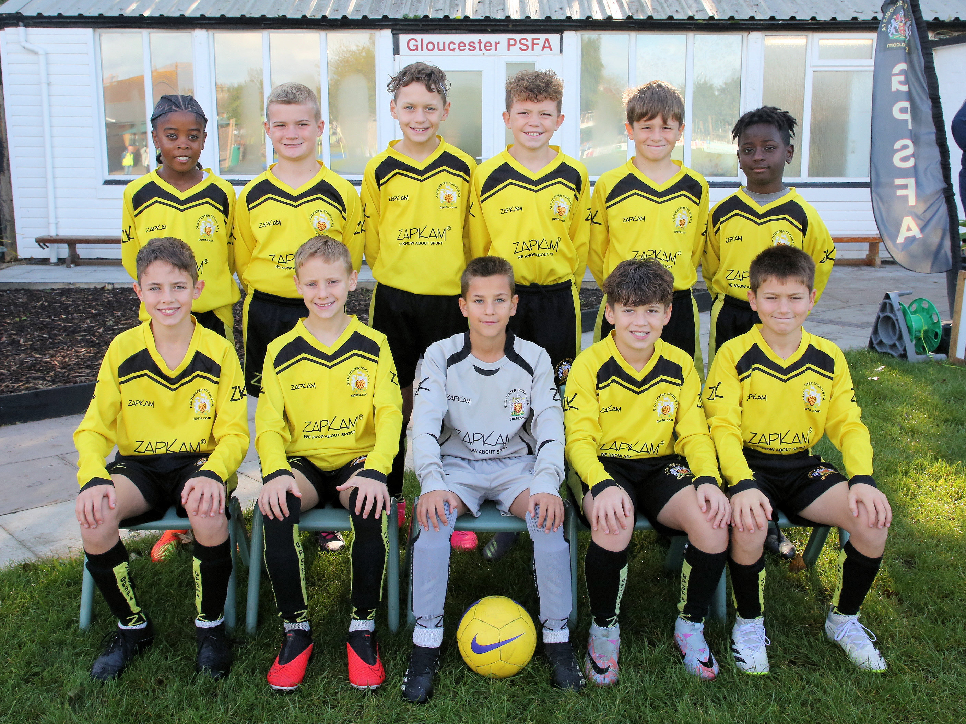
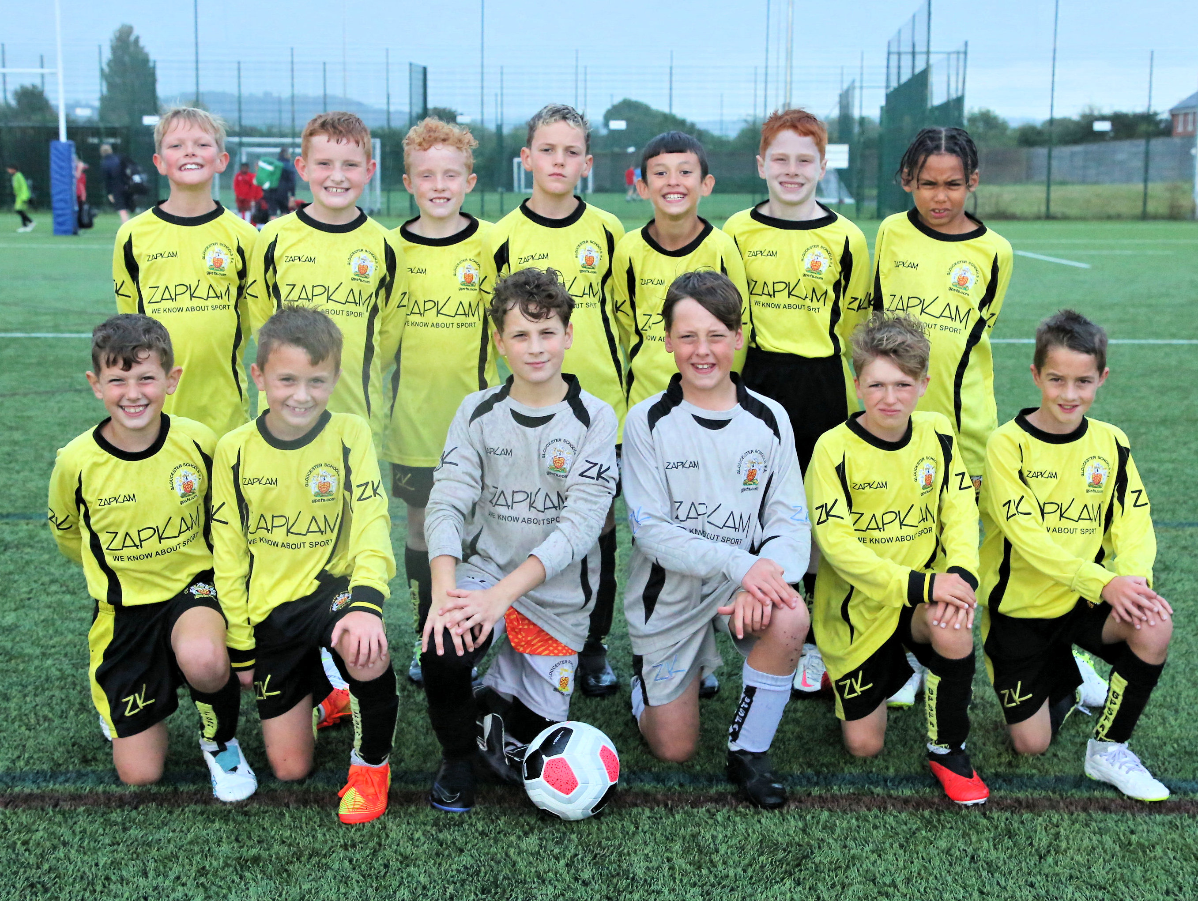

Please Respect
The Referee.

Our Sponsors –

948 Sports Foundation

Build4Space

We thank and appreciate our sponsors.

If you would like to be involved as a sponsor – please get in touch – stalbansprimaryschoolsfa@gmail.com

2023/24 Player Profiles

In today's programme, we have one of the Blues and Development Player's Profiles.

Name - Tom H
School - Fleetville
Nickname -
Playing position - Centre back/midfield
Favourite team - Manchester Utd
Best football moment - Scoring from the halfway line
Worst football moment - Getting nutmegged
Favourite food - Steak
Favourite drink - Fanta fruit twist
Hobbies - PS4
Favourite book - Mystery of the London Eye
Best subject - Maths
Worst subject - English
Favourite singer/group - 2Pac
Favourite TV - YouTube
Favourite film - Red Notice

Predictions 2023/24
Premier League - Man City
FA Cup - Man City
Champions League - Real Madrid
Relegated - Luton
Burnley
Everton

Name - Thomas NW
School - Garden Field
Nickname -
Playing position - Centre mid/Winger
Favourite team - Arsenal
Best football moment - Winning a cup double
Worst football moment - None yet
Favourite food - Curry
Favourite drink - Prime
Hobbies - Rugby, Basketball, Running
Favourite book - Tom Gates
Best subject - PE
Worst subject - English
Favourite singer/group - Eminem
Favourite TV - YouTube shorts
Favourite film - Guardians O.T.G

Predictions 2023/24
Premier League - Man City
FA Cup - Arsenal
Champions League - Man City
Relegated - Luton
Burnley
Sheff Utd

